‘ir’ Activity Sheet
Read each sound and circle the ir sounds  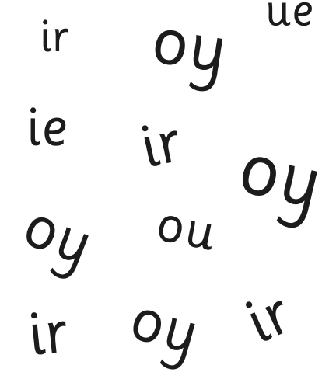 | 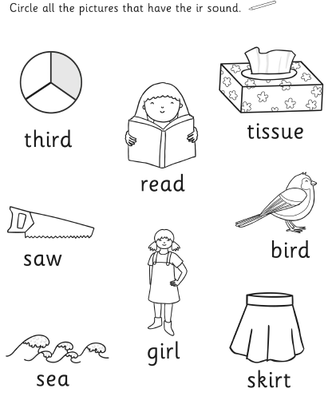

Draw a picture of something that has the ir sound.  What did you draw?___________________________________ | 