What I have already learned:
EYFS Understanding the World - ELG: The Natural World
Children at the expected level of development will:
- Explore the natural world around them, making observations and drawing
pictures of animals and plants;
- Know some similarities and differences between the natural world around
them and contrasting environments, drawing on their experiences and what
has been read in class;
- Understand some important processes and changes in the natural world
around them, including the seasons and changing states of matter.
What I will learn:
• I can describe what animals and humans need to survive.
• I can describe why exercise, a balanced diet and good hygiene are important for humans.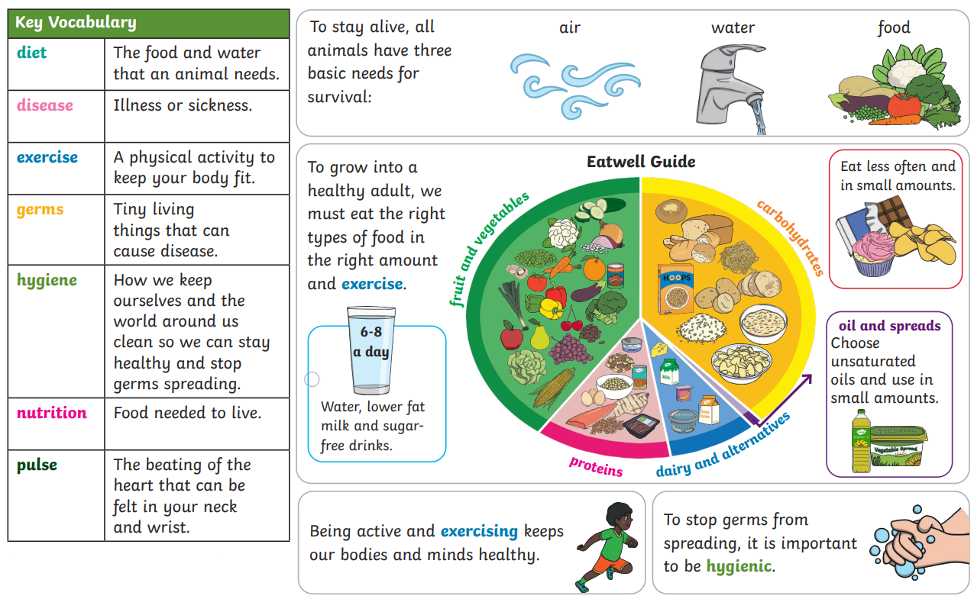
*courtesy of Twinkl
Vocabulary:  diet  disease  exercise  germs | hygiene  nutrition  pulse

