What I have already learned:
EYFS Understanding the World - ELG: The Natural World
Children at the expected level of development will:
- Explore the natural world around them, making observations and drawing
pictures of animals and plants;
- Know some similarities and differences between the natural world around
them and contrasting environments, drawing on their experiences and what
has been read in class;
- Understand some important processes and changes in the natural world
around them, including the seasons and changing states of matter.
What I will learn:
• I can distinguish between an object and the material it is made from.
• I can explain the materials that an object is made from.
• I can name wood, plastic, glass, metal, paper and rock.
• I can describe the properties of everyday materials.
• I can group objects based on the materials they are made from.
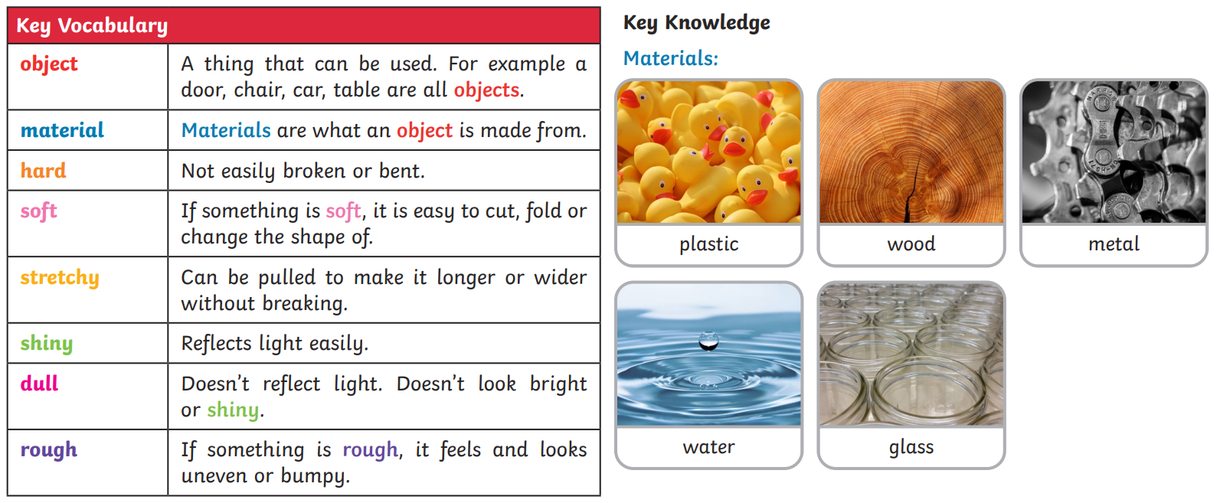
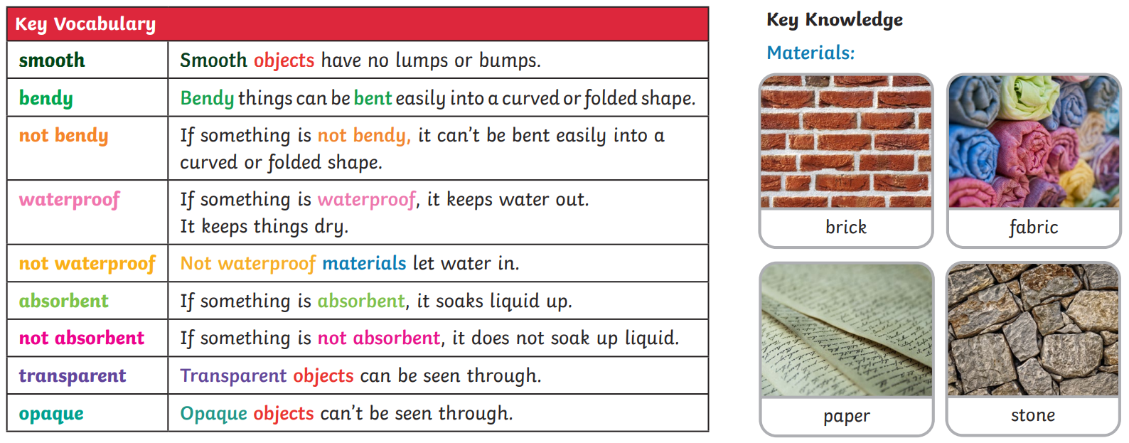
*courtesy of Twinkl
Vocabulary:  Material  Metal  Plastic  Wood | Glass  Water  Rock  Ceramic  Properties

