I can see the ball.

I can see a cow. | 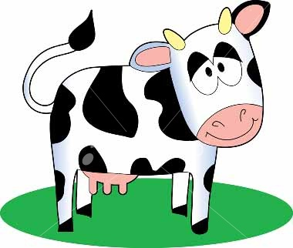

This is my cat.

This is a peg.

I like the dog.

We can see the hen.

Look at the cap.

This is a net.

You can see the
cup.

I can see the jug.

I can see a rat.

It is the sun.

