**Fishing for Verbs**

Verbs are ‘doing’ or ‘action’ words. They show what somebody or something is doing or feeling.

Colour in the fish that have a verb on them.

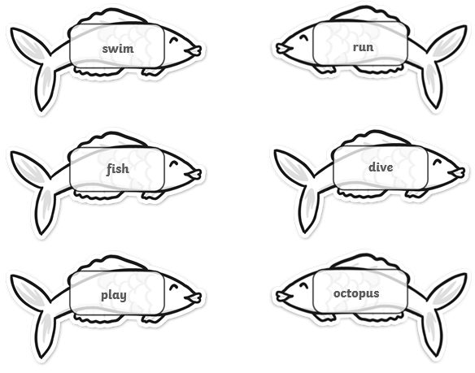

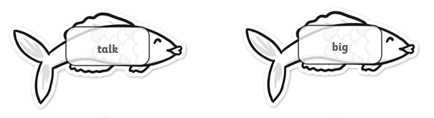

What verbs can you find in our story?