The Rainbow Fish  Reading Comprehension | 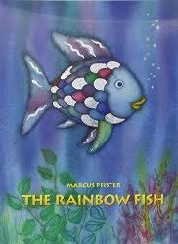
Tick the right box:
Where did the Rainbow Fish live? | The sea
 | A pond
What colour were the Rainbow Fish’s sparkly scales? | Gold
 | Silver
What colour was the little fish that followed the Rainbow Fish? | Yellow
 | Blue
How many shiny scales did the Rainbow Fish have? | One
 | Many
 | Three
Who lived in the dark cave? | A big brown fish
 | The Wise Octopus
How did giving away some of his shiny scales make the Rainbow Fish feel? | Angry
 | Sad
 | Happy
How many shiny scales did the Rainbow Fish have at the end of the story? | One
 | Ten
Did the Rainbow Fish have more or less friends at the end of the story? | More
 | Less

