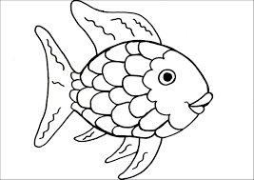 **The Rainbow Fish** 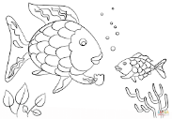

The Rainbow Fish changes during the story. Use the words below to describe what the Rainbow Fish is like at the beginning and end of the story. Can you think of some more words to describe the Rainbow fish?

|  |  |
| --- | --- |
| Beginning of the story | End of the story |
|  |  |

|  |  |  |  |
| --- | --- | --- | --- |
| rude | proud | happy | thoughtful |
| friendly | kind | lonely | nasty |