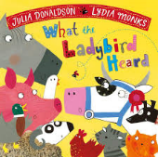

Adjectives - describing words

Adjectives are words that describe a person or item. What words are used to describe what the characters are like? Circle or highlight the adjectives.

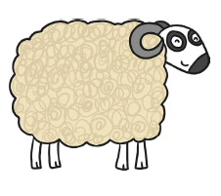Woolly sheep 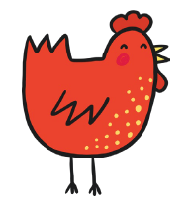

Red hen

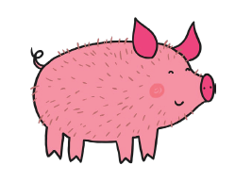 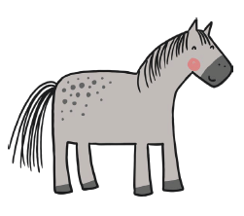Handsome horse

Hairy hog

Hefty Hugh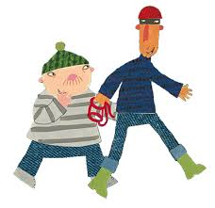Lanky Len